

Midterm Report

ARIMA Model

Advisor

Dr.Santitham Prom-on

Created By

Mr. Chainarong Tumapha ID: 58070503409 Section: C

CPE 301 Seminar

Computer Engineering Department

King Mongkut’s University of Technology Thonburi 2/2017

Introduction

Time series is a time sequence of observations on interested variable. It is used to forecast the future trend for analysing and making decision. For example, forecasting the stock for trading or the trend of product sale in business.

ARIMA model

To figure out the prediction, the ARIMA model is commonly used to forecast the future trend. The ARIMA model is a combination of 2 main models which are autoregressive and moving average model. then, use the integrated technique to eliminate non-stationary data.

Autoregressive

Autoregressive is a linear predictive model. It use the previous signal to predict the new signal by following this equation



where $φ$ are the parameters of the model, c is a constant, t is periode time, and $ϵt$ is an error.

Moving Average

This model use previous data to calculate the average data of N-span at T-period to visualize the pattern of data

let MT is moving average

MT  = yt

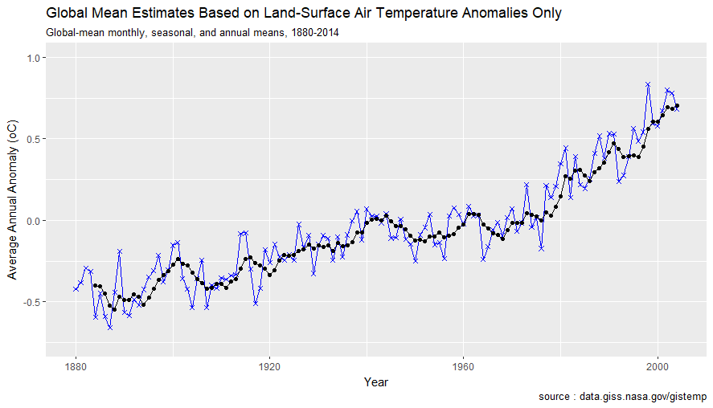

Figure 1 shows data ploting of simple moving average 5 spans and actual data

The blue cross symbol means actual value and the black dot is fits value with five-period moving average. As you see, the moving average line is depended on the previous data trend because it is generated from average of historical data.

Stationary

Series of data that does not change by seasonal and time. It indicates the stability in the data. There are two types of Stationary.Strictly stationary is a time series that its property does not change when shifted in time and weakly stationary has a constant mean and autocovariance that do not vary with respect to time.

Autocorrelation and Autocorrelation function

When origin time period value (yt) and another time period value (yt+k) vary together, this is called autocovariance with lag k. The autocovariance function is a collection of autocovariance. Notice that variance of the time series is an autocovariance which is no lag.

The autocorrelation coefficient at lag k can know by autocovariance at lag k divided by the variance of time series. The collection of autocorrelation coefficient is also called autocorrelation function(ACF). ACF can be used to indicate which one is stationary time series by plotting the graph to see the pattern. The stationary time series has own ACF pattern characteristic that act like sinusoidal pattern around zero in a short lag time. In contrast of nonstationary time series, it is very persistent decays very slowly in a long time lag.

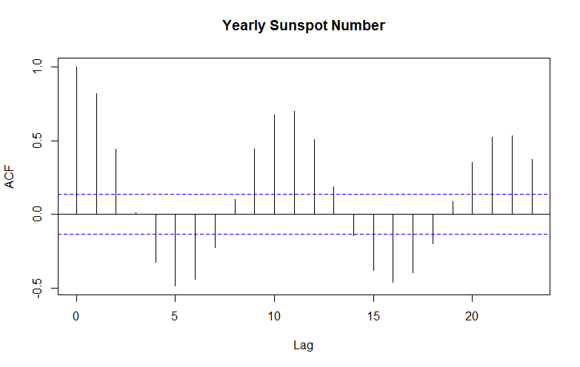

source : <http://www.macrotrends.net/stocks/charts/WFM/prices/whole-foods-mkt-stock-price-history>

peroide : 1811-2014

Figure 2 shows pattern of stationary data by plotting on autocorrelation function

The pattern of graph in figure 2 is looking sinusoidal graph with in a small periode.

The value of ACF is very vary by lag time. Thus, the data in the figure 2 is the stationary data.

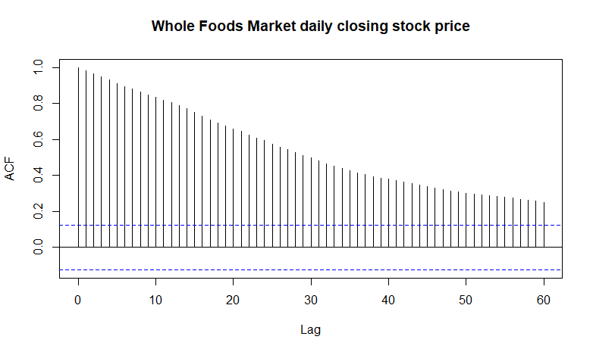

source : <http://www.macrotrends.net/stocks/charts/WFM/prices/whole-foods-mkt-stock-price-history>

date: 02/1/01 - 31/12/01

Figure 3 shows pattern of nonstationary data by plotting on autocorrelation function

In contrast of figure 2, figure 3 shows the slowly decrease trend. The ACF is not vary by lag time significantly. Therefore, this data in figure 3 is not stationary data or it is called nonstationary data.

Data tranformation

Data transform is often used for stabilizing the variance of the data. The equation of function that used to transform the data usually has logarithm function. The popular transformation to deal with nonconstant variance is the power family of transformation.

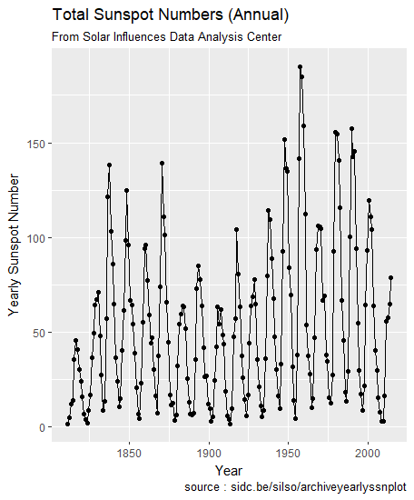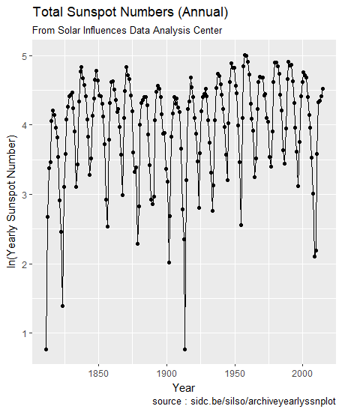

Figure 4.1(Left) shows raw data by the time.

Figure 4.2(Right) shows transformed data by the time.

The figure 4.2 is a data that was transformed by power family transformation. As you see between 1900-1975, the stabilize of data is increase more than the raw data which is plotted in figure 4.1. However, the formula which is used to transform the data in figure 4.2 also generated the some outliner.

Conclusion

ARIMA model is a model that use the historical data to forecast the future trend. It is used in business analysis and making decision. To make the ARIMA model effectively, the data must be clearly and minimum error. Thus,the process that optimize the error and clean the data is also very important.

References

6.4.2.1.Single Moving Average | Retrieved February 22, 2018, from<http://www.itl.nist.gov/div898/handbook/pmc/section4/pmc421.htm>

Stationary Process | Strict Stationarity & Weak Stationarity. (2016, March 28). Retrieved February 22, 2018, from <https://www.youtube.com/watch?v=eKa7veMDUzo>

Stationary process. (2018, February 22). Retrieved February 22, 2018, from <https://en.wikipedia.org/wiki/Stationary_process>

CHAPTER 4. STATIONARY TS MODELS | Retrieved February 22, 2018, from

<http://www.maths.qmul.ac.uk/~bb/TimeSeries/TS_Chapter4_2.pdf>

พจนานุกรมศัพท์สถิติคณิตศาสตร์ ฉบับราชบัณฑิตสภา. | Retrieved February 22, 2018, from<https://issuu.com/adulplus/docs/math_finish>

Covariance in Statistics: What is it? Example | Retrieved February 22, 2018, from <http://www.statisticshowto.com/covariance/>

Autocovariance and Autocorrelation | Retrieved February 22, 2018, from <https://www.mathstat.dal.ca/~stat5390/Section_3_ACF.pdf>

Autocorrelation | Retrieved February 22, 2018, from <http://www.statisticssolutions.com/autocorrelation/>

R: Geometric mean | Retrieved February 22, 2018, from <https://www.r-bloggers.com/r-geometric-mean/>

10.1 - Nonconstant Variance and Weighted Least Squares | Retrieved February 22, 2018, from <https://onlinecourses.science.psu.edu/stat462/node/186>

ARIMA เท่าที่เข้าใจ | Retrieved Mardch 3, 2018, from [http://www.algoaddict.com/arima-เท่าที่เข้าใจ/](http://www.algoaddict.com/arima-%E0%B9%80%E0%B8%97%E0%B9%88%E0%B8%B2%E0%B8%97%E0%B8%B5%E0%B9%88%E0%B9%80%E0%B8%82%E0%B9%89%E0%B8%B2%E0%B9%83%E0%B8%88/)

### Autoregressive (AR) Modeling | Retrieved March 3, 2018, from <https://www.sciencedirect.com/topics/neuroscience/autoregressive-model>

# 8.3 Autoregressive models | Retrieved March 3, 2018, from

https://www.otexts.org/fpp/8/3

Autoregressive integrated moving average | Retrieved March 3, 2018, from https://en.wikipedia.org/wiki/Autoregressive_integrated_moving_average

Autoregressive model | Retrieved March 3, 2018, from

https://en.wikipedia.org/wiki/Autoregressive_model

Montgomery, D. C., Jennings, C. L., & Kulahci, M. (2008). *Introduction to time series analysis and forecasting*. Hoboken, NJ: John Wiley.